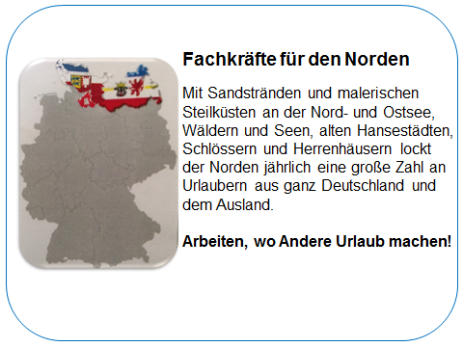
The International Personnel Service of ZAV is a member of the network of European employment services EURES - our service is free of charge for you!

For our pharmacy in Sternberg near Schwerin we are looking for

Pharmacist or pharmacist (m / w / d)

Your tasks:

• Distribution of medicines, medical devices, aids to patients and customers by prescription and free sale
• Advising patients and customers as well as medical staff about medicines and pharmacy products about
proper use, storage, side effects and risks
• the prescription of medicines
• Receipt inspection of recipe substances
• Carrying out standard pharmacy examinations and documentation

Your profile:

• University Degree
• Basic German
• independent, accurate work
• responsibility, team spirit
• communicative, friendly and customer-oriented

We offer:

• a permanent full-time job, also a part-time job is possible

Financial support: YFEJ „Your first EURES job“ funding program

For example:

Travel costs for interviews or German language course in your home country are possible (by applying for funds from the European mobility program YFEJ - Your First EURES Job)
Assistance during recognition process in Mecklenburg-Vorpommern.

Interested?

Send your CV or EUROPASS (www.europass-info.de) via e-mail code: Apotheke Sternberg to Mrs Ramona Haase : zav-ips-nord@arbeitsagentur.de

